TABLE OF CONTENTS
1. Cover Page
2. Certificate
3. Declaration
4. Acknowledgement
5. Abstract
6. List of Figures / List of Tables / Acronyms
7. Introduction
8. System Analysis
9. Database Design
10. ER Diagram
11. Relational Schema
12. Table Design
13. Normalization
14. SQL Implementation
15. SQL Queries & Screenshots
16. Conclusion & Future Enhancements
17. References

ABSTRACT
The Library Management System is designed to organize and manage the large volume of interconnected information that a library handles on a daily basis. Libraries routinely deal with data relating to books, authors, publishers, categories, members, librarians, suppliers, issue records, fines, and reservations. Maintaining such records manually or across disconnected files can lead to duplication, inconsistency, and difficulty in retrieving information.
The proposed system models the major library entities and the relationships between them using a relational database approach and stores the information in a centralized database that enforces data integrity through Primary Keys and Foreign Keys.
The database has been designed with ten major entities — Book, Member, Author, Category, Publisher, Librarian, Issue, Fine, Reservation, and Supplier — connected through well-defined relationships. The design is organized to reduce redundancy and maintain consistency in library records. The system is implemented using SQL, covering Data Definition Language (DDL) for table creation, Data Manipulation Language (DML) for sample records, and Data Query Language (DQL) for data retrieval, joins, aggregation, CRUD operations, and a database view.
The resulting design provides a structured foundation for book management, member management, book issuing, fine tracking, reservations, publisher and supplier management, and efficient retrieval of library information.

LIST OF FIGURES

Figure 1.Schema Diagram of the Library Management System

Figure 2. ER Diagram of the Library Management System

LIST OF TABLES

Table 1. Major Database Entities

Table 2. Entity Relationships and Cardinality

Table 3. Relational Schema Summary

Table 4. Author Table Structure

Table 5. Publisher Table Structure

Table 6. Category Table Structure

Table 7. Supplier Table Structure

Table 8. Book Table Structure

Table 9. Member Table Structure

Table 10. Librarian Table Structure

Table 11. Issue Table Structure

Table 12. Fine Table Structure

Table 13. Reservation Table Structure

Table 14. Keys and Constraints Summary

ACRONYMS
- DBMS – Database Management System
- ER – Entity Relationship
- SQL – Structured Query Language
- DDL – Data Definition Language
- DML – Data Manipulation Language
- DQL – Data Query Language
- DCL – Data Control Language
- TCL – Transaction Control Language
- PK – Primary Key
- FK – Foreign Key
- 1NF – First Normal Form
- 2NF – Second Normal Form
- 3NF – Third Normal Form

1. INTRODUCTION

1.1 Brief Information about the Project

The Library Management System is designed to organize and manage library information using a structured relational database. Libraries handle information related to books, authors, publishers, categories, members, librarians, suppliers, issue records, fines, and reservations.

The proposed system models these entities and their relationships using a relational database approach. The project focuses on designing the database structure, including entities, attributes, Primary Keys, Foreign Keys, relationships, and the ER diagram, and implementing it using SQL.

1.2 Motivation and Contribution of the Project

The project is motivated by the difficulties in managing library records manually or using separate files. A centralized database helps reduce data duplication, maintain consistency, and make information retrieval easier.

Centralizing library records in one database.

Reducing duplicate and inconsistent information.

Maintaining data integrity using Primary and Foreign Keys.

Supporting faster retrieval of book, member, and issue information.

Providing a foundation for book issue, fine, and reservation management.
1.3 Objectives of the Project
- Identify the major entities involved in the library management system.
- Identify suitable attributes for each entity.
- Establish relationships between the identified entities.
- Design an Entity–Relationship (ER) diagram.
- Convert the ER model into a relational database schema.
- Identify suitable Primary Keys and Foreign Keys.
- Reduce data duplication and maintain data consistency.
- Provide an organized database structure for efficient library record management.
1.4 Modules of the Project
The Module of the project covers the database-oriented management of core library information. The system manages books, authors, publishers, categories, suppliers, members, librarians, issue records, fines, and reservations.
The database can serve as the back end for a library management application and can be extended with modules such as online book search, automated notifications, digital library management, membership management, and advanced reporting.

2. SYSTEM ANALYSIS

2.1 Existing System

Manual or paper-based maintenance of book and member records.

Multiple files or spreadsheets for books, members, and issue details.

Duplicate records and inconsistent information.

Time-consuming searching for book availability and member details.

Difficulty in maintaining issue, fine, and reservation records.

Higher possibility of data-entry errors and lost records.

2.2 Proposed System

The proposed system uses a centralized relational database that connects library records through well-defined entities, relationships, Primary Keys, and Foreign Keys. It organizes library information into related tables and uses UNIQUE, NOT NULL, and CHECK constraints to maintain valid data.

Centralized library database with ten major entities.

Book, author, publisher, and category management.

Member and librarian record management.

Book issue and return record management.

Fine and payment-status management.

Book reservation management.

Supplier information management.

SQL-based data retrieval and reporting.

Referential integrity across related tables.
2.3 Functional Requirements
Module | Functional Requirement
Book Management | Add, update, search, and display book details.
Author Management | Store author details and associate authors with books.
Publisher Management | Store and maintain publisher information.
Category Management | Maintain book categories and descriptions.
Member Management | Register, update, search, and display member details.
Librarian Management | Store librarian details and manage librarian information.
Issue Management | Record book issue details, issue dates, due dates, and return dates.
Fine Management | Maintain fine amount, payment status, and payment date.
Reservation Management | Create and maintain book reservations for members.
Search and Reporting | Retrieve book, member, issue, fine, and reservation information using SQL queries.

2.4 Non-Functional Requirements

Performance – Queries on book, member, and issue data should return results efficiently.

Integrity – Invalid references and duplicate key values must be prevented.

Security – Library information should be accessible only to authorized users.

Usability – The database structure should be understandable and easy to use.

Reliability – Database operations should maintain a consistent database state.

Scalability – The design should support growth in books, members, and library

2.5 Requirements Specification
Category | Requirement
Hardware | Intel i3 or above; 4 GB RAM minimum; adequate storage; standard display and keyboard/mouse.
Operating System | Windows 10/11 or an equivalent supported platform.
Database | MySQL Relational Database Management System.

3. DATABASE DESIGN

3.1 Major Entities

Table 1: Major Database Entities
Entity | Description
AUTHOR | Stores author details such as name, email, and phone number.
PUBLISHER | Stores publisher details including name, email, phone, and address.
CATEGORY | Stores book categories and their descriptions.
SUPPLIER | Stores supplier details such as name, email, phone, and address.
BOOK | Stores book details including name, ISBN, quantity, and availability.
MEMBER | Stores library member details such as name, department, email, and phone.
LIBRARIAN | Stores librarian details and login-related information.
ISSUE | Represents the issue and return details of books issued to members.

FINE | Stores fine amount, payment status, and payment date for issued books.
RESERVATION | Stores book reservation details made by members.

3.2 ER Model

The Entity–Relationship (ER) model represents the major entities of the Library Management System and the relationships between them. The BOOK entity is connected with AUTHOR, PUBLISHER, CATEGORY, SUPPLIER, ISSUE, and RESERVATION. MEMBER is connected with ISSUE and RESERVATION, while LIBRARIAN manages issue records. The ISSUE entity is associated with FINE for fine management.

The ER model provides a clear representation of how library records are connected and forms the basis for converting the conceptual design into a relational database schema.

3.3 Relationships and Cardinality

Table 2: Entity Relationships and Cardinality
Relationship | Cardinality | Meaning
AUTHOR – BOOK | 1 : M | One author can be associated with many books.
PUBLISHER – BOOK | 1 : M | One publisher can publish many books.
CATEGORY – BOOK | 1 : M | One category can contain many books.
SUPPLIER – BOOK | 1 : M | One Supplier Can Supply Many Books,and each Book Supplied By a Primary Supplier.
BOOK – ISSUE | 1 : M | One book can have many issue records.
MEMBER – ISSUE | 1 : M | One member can have many issue records.
LIBRARIAN – ISSUE | 1 : M | One librarian can manage many issue records.
MEMBER – RESERVATION | 1 : M | One member can make many reservations.
BOOK – RESERVATION | 1 : M | One book can have many reservation records.
ISSUE – FINE | 1 : 1 | One issue record can have one associated fine record.

4. ER DIAGRAM
Figure 1: Schema Diagram of the Library Management System

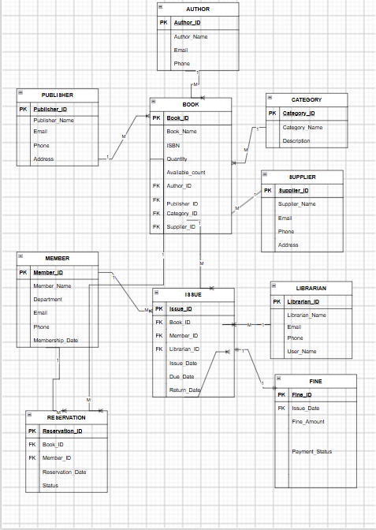

The Schema diagram shows the ten entities of the Library Management System and the relationships between them. Primary Keys (PK) and Foreign Keys (FK) are marked within each entity box, consistent with the relational schema and SQL implementation presented in the following sections.

Figure 2: ER Diagram of the Library Management System

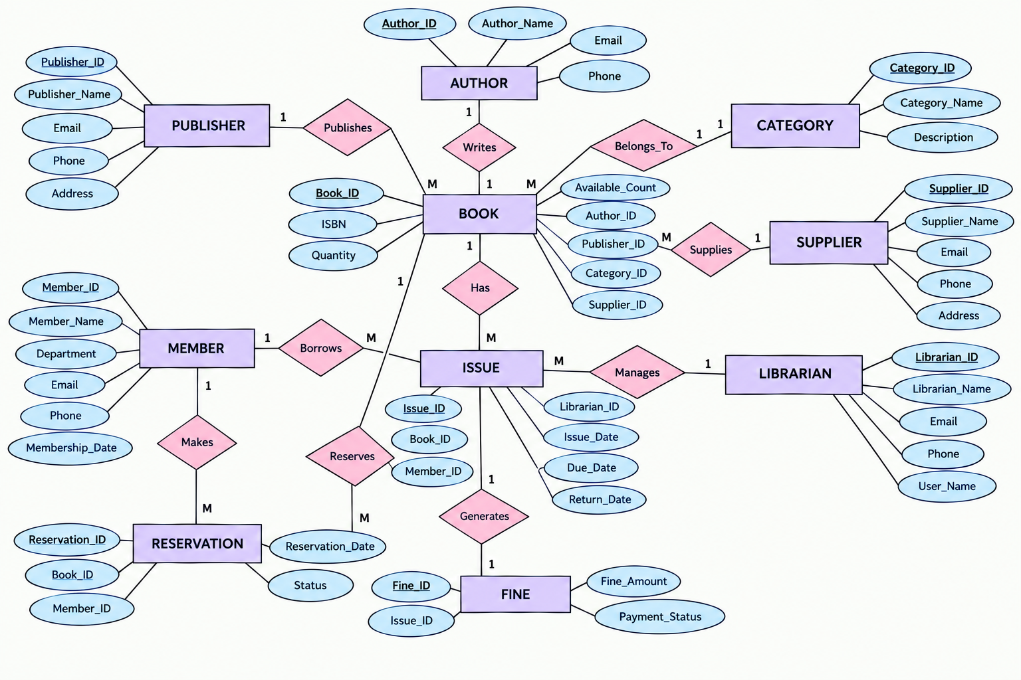

The ten entities are Author, Publisher, Category, Supplier, Book, Member, Librarian, Issue, Fine, and Reservation. The diagram represents their relationships and cardinality for managing books, members, book issues, fines, and reservations

5. RELATIONAL SCHEMA

The relational schema below follows the table-creation order used in the SQL implementation, so that every Foreign Key refers to an appropriate parent table. The schema represents the ten entities of the Library Management System and their keys.

Table 3: Relational Schema Summary
Relation | Relational Schema | Keys
AUTHOR | Author(Author_ID, Author_Name, Email, Phone) | PK: Author_ID
PUBLISHER | Publisher(Publisher_ID, Publisher_Name, Email, Phone, Address) | PK: Publisher_ID
CATEGORY | Category(Category_ID, Category_Name, Description) | PK: Category_ID
SUPPLIER | Supplier(Supplier_ID, Supplier_Name, Email, Phone, Address) | PK: Supplier_ID
BOOK | Book(Book_ID, Book_Name, ISBN, Quantity, Available_Count, Author_ID, Publisher_ID, Category_ID, Supplier_ID) | PK: Book_ID; FK: Author_ID, Publisher_ID, Category_ID,  Supplier_ID
MEMBER | Member(Member_ID, Member_Name, Department, Email, Phone, Membership_Date) | PK: Member_ID
LIBRARIAN | Librarian(Librarian_ID, Librarian_Name, Email, Phone, User_Name) | PK: Librarian_ID
ISSUE | Issue(Issue_ID, Book_ID, Member_ID, Librarian_ID, Issue_Date, Due_Date, Return_Date) | PK: Issue_ID; FK: Book_ID, Member_ID, Librarian_ID
FINE | Fine(Fine_ID, Issue_ID, Fine_Amount, Payment_Status, Payment_Date) | PK: Fine_ID; FK: Issue_ID
RESERVATION | Reservation(Reservation_ID, Book_ID, Member_ID, Reservation_Date, Status) | PK: Reservation_ID; FK: Book_ID, Member_ID

The BOOK relation references AUTHOR, PUBLISHER,Supplier, and CATEGORY. ISSUE references BOOK, MEMBER, And LIBRARIAN. FINE references ISSUE, while RESERVATION references BOOK and MEMBER. These Foreign Key relationships maintain the connections between the related tables.

6.TABLE DESIGN
6.1 Author Table
Table 4: Author Table Structure
Attribute | Data Type | Constraint | Description
Author_ID | INT | PK | Unique author identifier
Author_Name | VARCHAR(100) | NOT NULL | Name of the author
Email | VARCHAR(100) | UNIQUE | Author email address
Phone | VARCHAR(15) | — | Author contact number

6.2 Publisher Table
Table 5: Publisher Table Structure
Attribute | Data Type | Constraint | Description
Publisher_ID | INT | PK | Unique publisher identifier
Publisher_Name | VARCHAR(100) | NOT NULL | Name of the publisher
Email | VARCHAR(100) | UNIQUE | Publisher email address
Phone | VARCHAR(15) | — | Publisher contact number
Address | VARCHAR(200) | — | Publisher address

6.3 Category Table
Table 6: Category Table Structure
Attribute | Data Type | Constraint | Description
Category_ID | INT | PK | Unique category identifier
Category_Name | VARCHAR(100) | NOT NULL, UNIQUE | Name of the book category
Description | VARCHAR(200) | — | Description of the category

6.4 Supplier Table
Table 7: Supplier Table Structure
Attribute | Data Type | Constraint | Description
Supplier_ID | INT | PK | Unique supplier identifier
Supplier_Name | VARCHAR(100) | NOT NULL | Name of the supplier
Email | VARCHAR(100) | UNIQUE | Supplier email address
Phone | VARCHAR(15) | — | Supplier contact number
Address | VARCHAR(200) | — | Supplier address

6.5 Book Table
Table 8: Book Table Structure
Attribute | Data Type | Constraint | Description
Book_ID | INT | PK | Unique book identifier
Book_Name | VARCHAR(200) | NOT NULL | Name of the book
ISBN | VARCHAR(20) | UNIQUE | International Standard Book Number
Quantity | INT | NOT NULL, CHECK (Quantity >= 0) | Total number of copies
Available_Count | INT | NOT NULL, CHECK (Available_Count >= 0) | Number of currently available copies
Author_ID | INT | FK | References Author
Publisher_ID | INT | FK | References Publisher
Category_ID | INT | FK | References Category
Supplier_ID | INT | FK | References  Supplier

6.6 Member Table
Table 9: Member Table Structure
Attribute | Data Type | Constraint | Description
Member_ID | INT | PK | Unique member identifier
Member_Name | VARCHAR(100) | NOT NULL | Name of the library member
Department | VARCHAR(100) | — | Member's department
Email | VARCHAR(100) | UNIQUE | Member email address
Phone | VARCHAR(15) | — | Member contact number
Membership_Date | DATE | DEFAULT (CURRENT_DATE) | Date of membership

6.7 Librarian Table
Table 10: Librarian Table Structure
Attribute | Data Type | Constraint | Description
Librarian_ID | INT | PK | Unique librarian identifier
Librarian_Name | VARCHAR(100) | NOT NULL | Name of the librarian
Email | VARCHAR(100) | UNIQUE | Librarian email address
Phone | VARCHAR(15) | — | Librarian contact number
User_Name | VARCHAR(50) | UNIQUE | Unique librarian username

6.8 Issue Table
Table 11: Issue Table Structure
Attribute | Data Type | Constraint | Description
Issue_ID | INT | PK | Unique issue identifier
Book_ID | INT | NOT NULL, FK | References Book
Member_ID | INT | NOT NULL, FK | References Member
Librarian_ID | INT | NOT NULL, FK | References Librarian
Issue_Date | DATE | DEFAULT (CURRENT_DATE) | Date when the book was issued
Due_Date | DATE | NOT NULL | Date by which the book should be returned
Return_Date | DATE | — | Actual date of book return

6.9 Fine Table
Table 12: Fine Table Structure
Attribute | Data Type | Constraint | Description
Fine_ID | INT | PK | Unique fine identifier
Issue_ID | INT | UNIQUE, FK | References Issue
Fine_Amount | DECIMAL(10,2) | DEFAULT 0, CHECK (Fine_Amount >= 0) | Amount of fine
Payment_Status | VARCHAR(20) | DEFAULT 'Pending' | Status of fine payment
Payment_Date | DATE | — | Date on which fine was paid

6.10 Reservation Table
Table 13: Reservation Table Structure
Attribute | Data Type | Constraint | Description
Reservation_ID | INT | PK | Unique reservation identifier
Book_ID | INT | NOT NULL, FK | References Book
Member_ID | INT | NOT NULL, FK | References Member
Reservation_Date | DATE | DEFAULT (CURRENT_DATE) | Date of reservation
Status | VARCHAR(20) | DEFAULT 'Pending' | Current reservation status

6.11 Keys and Constraints
Table 14: Keys and Constraints Summary
Constraint Type | Applied To / Purpose
Primary Key | Author_ID, Publisher_ID, Category_ID, Supplier_ID, Book_ID, Member_ID, Librarian_ID, Issue_ID, Fine_ID, Reservation_ID
Foreign Key | Book.Author_ID, Book.Publisher_ID, Book.Category_ID, Book.Supplier_ID; Issue.Book_ID, Issue.Member_ID, Issue.Librarian_ID; Fine.Issue_ID; Reservation.Book_ID, Reservation.Member_ID
NOT NULL | Required fields such as names, identifiers, quantities, and important issue/reservation details
UNIQUE | Author.Email, Publisher.Email, Category.Category_Name, Supplier.Email, Book.ISBN, Member.Email, Librarian.Email, Librarian.User_Name, Fine.Issue_ID
CHECK | Book.Quantity >= 0, Book.Available_Count >= 0, Fine.Fine_Amount >= 0
DEFAULT | Member.Membership_Date, Issue.Issue_Date, Fine.Fine_Amount, Fine.Payment_Status, Reservation.Reservation_Date, Reservation.Status
ALTER TABLE | Book_Name is modified to VARCHAR(200) after table creation
The keys and constraints help maintain entity integrity, referential integrity, uniqueness, valid values, and consistent library records.

7. NORMALIZATION

Normalization organizes the Library Management System data into related relations to reduce data redundancy, inconsistency, and update anomalies. The database is designed up to the Third Normal Form (3NF).

7.1 Unnormalized Form (UNF)

In an Unnormalized library record, information about books, authors, publishers, categories, members, issues, fines, and reservations may be stored together in a single record.
For example, one record could contain:
- Book details
- Author and publisher details
- Member details
- Issue and return details
- Fine information
- Reservation information
Repeating book, author, member, issue, and reservation information can cause data redundancy and inconsistency.

7.2 First Normal Form (1NF)

In 1NF, repeating groups are removed and each attribute contains a single atomic value.
For the Library Management System:
- Each book is represented as an individual record.
- Each member is represented as an individual record.
- Each issue is represented as a separate record.
- Each reservation is represented as a separate record.
- Each fine is represented as a separate record.
- Attributes contain single values rather than multiple values.
The data is therefore divided into related tables such as BOOK, MEMBER, AUTHOR, PUBLISHER, CATEGORY, ISSUE, FINE, and RESERVATION.

7.3 Second Normal Form (2NF)

In 2NF, partial dependencies are removed so that non-key attributes depend on the complete primary key.
In the Library Management System:
- Book-specific attributes depend on Book_ID.
- Member-specific attributes depend on Member_ID.
- Author-specific attributes depend on Author_ID.
- Publisher-specific attributes depend on Publisher_ID.
- Category-specific attributes depend on Category_ID.
- Issue-specific attributes depend on Issue_ID.
- Fine-specific attributes depend on Fine_ID.
- Reservation-specific attributes depend on Reservation_ID.

7.4 Third Normal Form (3NF)

In 3NF, transitive dependencies are removed. Independent information is stored in separate relations rather than being repeated in other tables.
For the Library Management System:
- AUTHOR stores author information instead of repeating it in BOOK.
- PUBLISHER stores publisher information instead of repeating it in BOOK.
- CATEGORY stores category information separately.
- SUPPLIER stores supplier information separately.
- MEMBER stores member information independently of ISSUE and RESERVATION.
- LIBRARIAN stores librarian information independently of ISSUE.
- FINE stores fine information separately from ISSUE.
- RESERVATION stores reservation information separately from BOOK and MEMBER.
The resulting ten relations are Author, Publisher, Category, Supplier, Book, Member, Librarian, Issue, Fine, and Reservation, corresponding to the tables implemented in the SQL database. This structure reduces redundancy and helps maintain data consistency.

8. SQL IMPLEMENTATION
The Library Management System is implemented using SQL in the LibraryDB database. The SQL implementation includes Data Definition Language (DDL), Data Manipulation Language (DML), and Data Query Language (DQL) operations. The tables are created in an order that satisfies the Foreign Key dependencies between the entities.

8.1 DDL – Data Definition Language
DDL commands are used to create and modify the structure of the Library Management System database. The implementation uses CREATE DATABASE, CREATE TABLE, ALTER TABLE, DESC, and SHOW TABLES.
-- Create Database
CREATE DATABASE LibraryDB;

-- Use Database
USE LibraryDB;

-- 1. AUTHOR TABLE
CREATE TABLE Author (
Author_ID INT PRIMARY KEY,
Author_Name VARCHAR(100) NOT NULL,
Email VARCHAR(100) UNIQUE,
Phone VARCHAR(15)
);

-- 2. PUBLISHER TABLE
CREATE TABLE Publisher (
Publisher_ID INT PRIMARY KEY,
Publisher_Name VARCHAR(100) NOT NULL,
Email VARCHAR(100) UNIQUE,
Phone VARCHAR(15),
Address VARCHAR(200)
);

-- 3. CATEGORY TABLE
CREATE TABLE Category (
Category_ID INT PRIMARY KEY,
Category_Name VARCHAR(100) NOT NULL UNIQUE,
Description VARCHAR(200)
);

-- 4. SUPPLIER TABLE
CREATE TABLE Supplier (
Supplier_ID INT PRIMARY KEY,
Supplier_Name VARCHAR(100) NOT NULL,
Email VARCHAR(100) UNIQUE,
Phone VARCHAR(15),
Address VARCHAR(200)
);

-- 5. BOOK TABLE
CREATE TABLE Book (
Book_ID INT PRIMARY KEY,
Book_Name VARCHAR(200) NOT NULL,
ISBN VARCHAR(20) UNIQUE,
Quantity INT NOT NULL CHECK (Quantity >= 0),
Available_Count INT NOT NULL CHECK (Available_Count >= 0),
Author_ID INT,
Publisher_ID INT,
Category_ID INT,
Supplier_ID INT,

FOREIGN KEY (Author_ID)
REFERENCES Author(Author_ID),

FOREIGN KEY (Publisher_ID)
REFERENCES Publisher(Publisher_ID),

FOREIGN KEY (Category_ID)
REFERENCES Category(Category_ID),

FOREIGN KEY (Supplier_ID)
REFERENCES Supplier(Supplier_ID)
);

-- 6. MEMBER TABLE
CREATE TABLE Member (
Member_ID INT PRIMARY KEY,
Member_Name VARCHAR(100) NOT NULL,
Department VARCHAR(100),
Email VARCHAR(100) UNIQUE,
Phone VARCHAR(15),
Membership_Date DATE DEFAULT (CURRENT_DATE)
);

-- 7. LIBRARIAN TABLE
CREATE TABLE Librarian (
Librarian_ID INT PRIMARY KEY,
Librarian_Name VARCHAR(100) NOT NULL,
Email VARCHAR(100) UNIQUE,
Phone VARCHAR(15),
User_Name VARCHAR(50) UNIQUE
);

-- 8. ISSUE TABLE
CREATE TABLE Issue (
Issue_ID INT PRIMARY KEY,
Book_ID INT NOT NULL,
Member_ID INT NOT NULL,
Librarian_ID INT NOT NULL,
Issue_Date DATE DEFAULT (CURRENT_DATE),
Due_Date DATE NOT NULL,
Return_Date DATE,

FOREIGN KEY (Book_ID)
REFERENCES Book(Book_ID),

FOREIGN KEY (Member_ID)
REFERENCES Member(Member_ID),

FOREIGN KEY (Librarian_ID)
REFERENCES Librarian(Librarian_ID)
);

-- 9. FINE TABLE
CREATE TABLE Fine (
Fine_ID INT PRIMARY KEY,
Issue_ID INT UNIQUE,
Fine_Amount DECIMAL(10,2) DEFAULT 0 CHECK (Fine_Amount >= 0),
Payment_Status VARCHAR(20) DEFAULT 'Pending',
Payment_Date DATE,

FOREIGN KEY (Issue_ID)
REFERENCES Issue(Issue_ID)
);

-- 10. RESERVATION TABLE
CREATE TABLE Reservation (
Reservation_ID INT PRIMARY KEY,
Book_ID INT NOT NULL,
Member_ID INT NOT NULL,
Reservation_Date DATE DEFAULT (CURRENT_DATE),
Status VARCHAR(20) DEFAULT 'Pending',

FOREIGN KEY (Book_ID)
REFERENCES Book(Book_ID),

FOREIGN KEY (Member_ID)
REFERENCES Member(Member_ID)
);

ALTER TABLE Book
MODIFY Book_Name VARCHAR(200);

DESC Book;
show tables;

8.2 DML – Data Manipulation Language
DML commands are used to insert, update, and delete records from the database. Sample records are inserted into all the major tables, followed by UPDATE and DELETE operations.
INSERT INTO Author
VALUES
(1, 'A.P.J. Abdul Kalam', 'kalam@gmail.com', '9876543210'),
(2, 'R.K. Narayan', 'narayan@gmail.com', '9876543211');

INSERT INTO Publisher
VALUES
(1, 'Penguin Books', 'penguin@gmail.com', '9876543220', 'New Delhi'),
(2, 'Oxford Press', 'oxford@gmail.com', '9876543221', 'Hyderabad');

INSERT INTO Category
VALUES
(1, 'Biography', 'Life stories of famous people'),
(2, 'Fiction', 'Fictional stories and novels');

INSERT INTO Supplier
VALUES
(1, 'ABC Book Suppliers', 'abc@gmail.com', '9876543230', 'Vijayawada'),
(2, 'Books World', 'books@gmail.com', '9876543231', 'Visakhapatnam');

INSERT INTO Member
VALUES
(101, 'Vamsi', 'AIML', 'vamsi@gmail.com', '9876543240', '2026-06-10'),
(102, 'Surya', 'CSE', 'surya@gmail.com', '9876543241', '2026-06-12');

INSERT INTO Librarian
VALUES
(1, 'Ramesh', 'ramesh@gmail.com', '9876543250', 'ramesh01'),
(2, 'Suresh', 'suresh@gmail.com', '9876543251', 'suresh01');

INSERT INTO Book
VALUES
(101, 'Wings of Fire', '978030', 10, 8, 1, 1, 1),
(102, 'Malgudi Days', '978031', 8, 6, 2, 2, 2);

INSERT INTO Issue
VALUES
(1, 101, 101, 1, '2026-09-01', '2026-09-15', '2026-09-14'),
(2, 102, 102, 2, '2026-09-05', '2026-09-19', NULL);

INSERT INTO Fine
VALUES
(1, 1, 10.00, 'Paid', '2026-09-14');

INSERT INTO Reservation
VALUES
(1, 101, 102, '2026-09-20', 'Active'),
(2, 102, 101, '2026-09-21', 'Completed');

UPDATE Book
SET Available_Count = 7
WHERE Book_ID = 101;

UPDATE Member
SET Phone = '9999999999'
WHERE Member_ID = 101;

DELETE FROM Reservation
WHERE Reservation_ID = 2;

8.3 DQL – Data Query Language
DQL commands are used to retrieve and filter information stored in the Library Management System database. The implementation demonstrates SELECT, WHERE, ORDER BY, DISTINCT, LIKE, IS NOT NULL, and JOIN queries.
USE LibraryDB;

-- 1. Display all books
SELECT * FROM Book;

-- 2. Display only required book details
SELECT Book_ID, Book_Name, ISBN
FROM Book;
-- 3. Display books with available copies
SELECT Book_ID, Book_Name, Available_Count
FROM Book
WHERE Available_Count > 0;

-- 4. Display books in descending order of quantity
SELECT Book_ID, Book_Name, Quantity
FROM Book
ORDER BY Quantity DESC;

-- 5. Display different publishers
SELECT DISTINCT Publisher_ID
FROM Book;

-- 6. Search books by name
SELECT Book_ID, Book_Name
FROM Book
WHERE Book_Name LIKE '%Fire%';

-- 7. Display books having available count
SELECT Book_ID, Book_Name, Available_Count
FROM Book
WHERE Available_Count IS NOT NULL;

-- 8. Display issued books with member details
SELECT Book.Book_Name, Member.Member_Name, Issue.Issue_Date
FROM Book
JOIN Issue ON Book.Book_ID = Issue.Book_ID

JOIN Member ON Issue.Member_ID = Member.Member_ID;

9. SQL QUERIES & SCREENSHOTS
The queries below demonstrate the major SQL operations used in the Library Management System. They include CRUD operations, JOIN queries, aggregate functions, grouping, and a database view,also Subquery. A screenshot of the MySQL output can be inserted after each query during final documentation. The organization follows the structure of the example DBMS documentation.

9.1 CRUD Operations
CRUD stands for Create, Read, Update, and Delete. These operations are used to manage book records in the Library Management System.
USE LibraryDB;
-- 1. CREATE – Add a new book
INSERT INTO Book
VALUES (105, 'Wings of Fire', '978035', 8, 8, 1, 1, 1);
Output:
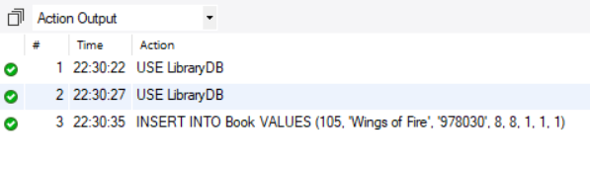
-- 2. READ – Display the book
SELECT *
FROM Book
WHERE Book_ID = 105;
Output:

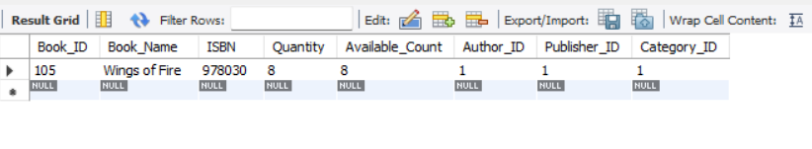
-- 3. UPDATE – Change available book count
UPDATE Book
SET Available_Count = 6
WHERE Book_ID = 105;
-- Check updated record
SELECT *
FROM Book
WHERE Book_ID = 105;
Output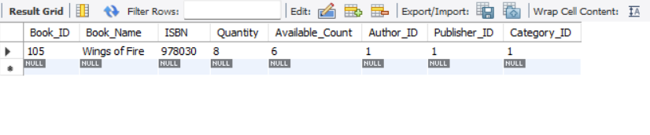

-- 4. DELETE – Delete the book

DELETE FROM Book

WHERE Book_ID = 105;

-- Check deletion

SELECT *

FROM Book

WHERE Book_ID = 105;

Output:

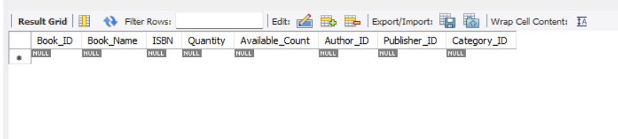

9.2 Joins

-- 1. Display books with author names

SELECT Book.Book_ID, Book.Book_Name, Author.Author_Name

FROM Book

INNER JOIN Author

ON Book.Author_ID = Author.Author_ID;

Output:

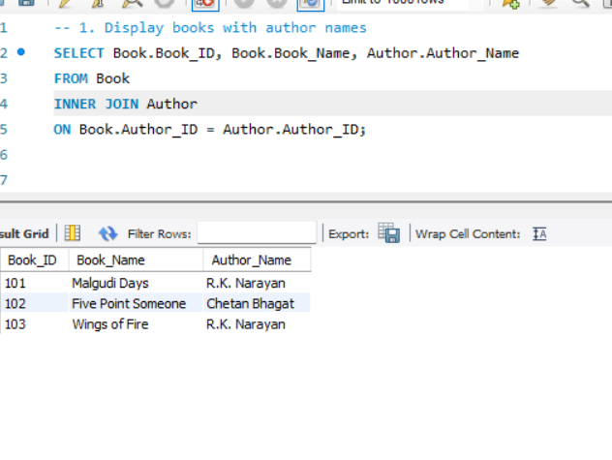
-- 2. Display books with publisher names
SELECT Book.Book_ID, Book.Book_Name, Publisher.Publisher_Name
FROM Book
INNER JOIN Publisher
ON Book.Publisher_ID = Publisher.Publisher_ID;

Output:
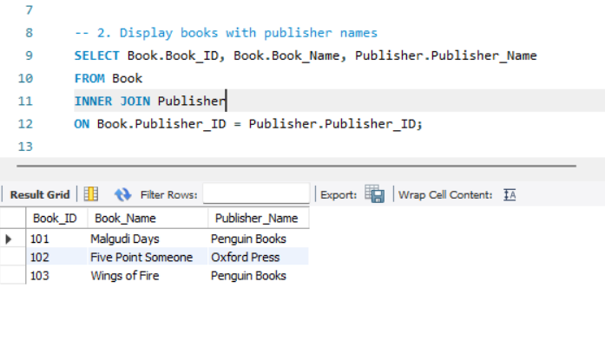
-- 3. Display books with category names
SELECT Book.Book_ID, Book.Book_Name, Category.Category_Name
FROM Book
INNER JOIN Category
ON Book.Category_ID = Category.Category_ID;

Output:
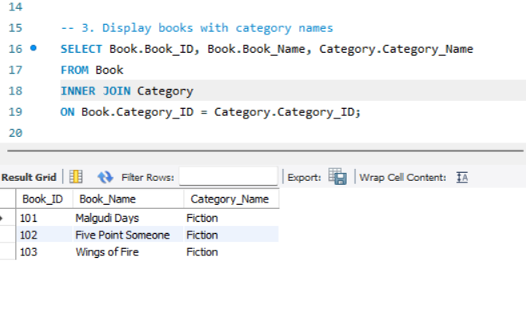

-- 4. Display issued books with member details
SELECT Book.Book_Name, Member.Member_Name,
Issue.Issue_Date, Issue.Due_Date
FROM Issue
INNER JOIN Book
ON Issue.Book_ID = Book.Book_ID
INNER JOIN Member
ON Issue.Member_ID = Member.Member_ID;

Output:
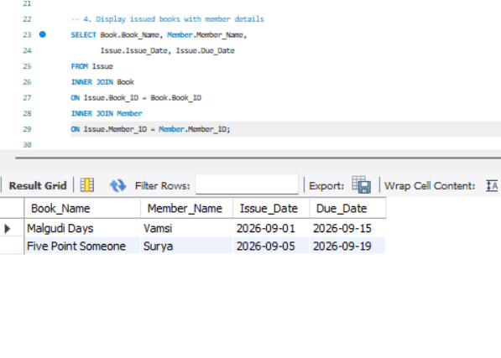
-- 5. Display issue details with fine information
SELECT Issue.Issue_ID, Issue.Book_ID,
Fine.Fine_Amount, Fine.Payment_Status
FROM Issue
INNER JOIN Fine
ON Issue.Issue_ID = Fine.Issue_ID;

Output:
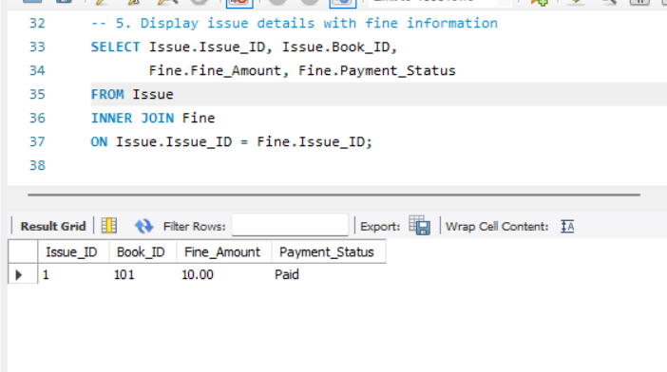

9.3 Aggregation & Grouping

-- 1. COUNT() – Count total number of books

SELECT COUNT(*) AS Total_Books

FROM Book;

Output:

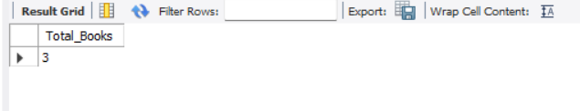

-- 2. AVG() – Find average book quantity

SELECT AVG(Quantity) AS Average_Quantity

FROM Book;

Output:

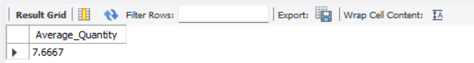
-- 3. MAX() – Find maximum book quantity
SELECT MAX(Quantity) AS Maximum_Quantity
FROM Book;
Output:
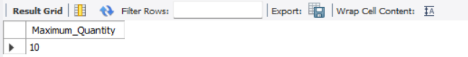
-- 4. MIN() – Find minimum book quantity
SELECT MIN(Quantity) AS Minimum_Quantity
FROM Book;
Output:
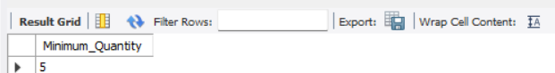
-- 5. SUM() – Find total number of books
SELECT SUM(Quantity) AS Total_Quantity
FROM Book;
Output:
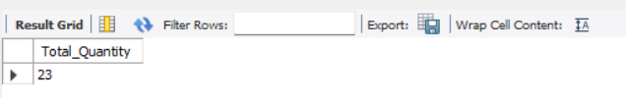
-- 6. GROUP BY – Count books for each category
SELECT Category_ID, COUNT(*) AS Total_Books
FROM Book
GROUP BY Category_ID;
Output:

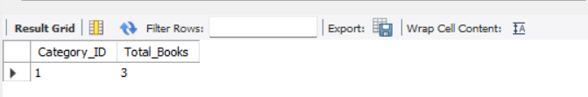
-- 7. HAVING – Show categories having more than 1 book
SELECT Category_ID, COUNT(*) AS Total_Books
FROM Book
GROUP BY Category_ID
HAVING COUNT(*) > 1;
Output:
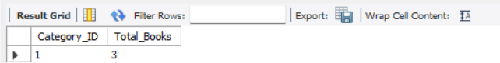

9.4 View

USE LibraryDB;
CREATE VIEW Library_Book_View AS
SELECT
Book_ID,
Book_Name,
ISBN,
Quantity,
Available_Count
FROM Book;

SELECT * FROM Library_Book_View;

Output:
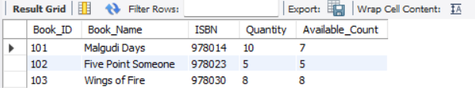

9.5 Subquery

-- Find books with quantity greater than average quantity

SELECT Book_Name, Quantity

FROM Book

WHERE Quantity > (

SELECT AVG(Quantity)

FROM Book

);

Output:

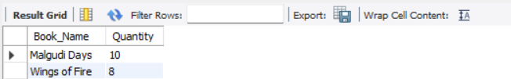

--Subquery With Equality Operator = (Example)

SELECT Book_Name

FROM Book

WHERE Author_ID = (

SELECT Author_ID

FROM Author

WHERE Author_Name = 'R.K. Narayan'

);

Output:

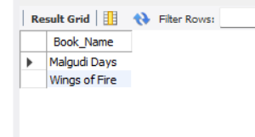

10. CONCLUSION
The Library Management System provides a structured relational database solution for managing core library information. The design organizes books, authors, publishers, categories, suppliers, members, librarians, issues, fines, and reservations into ten related tables.

Primary Keys, Foreign Keys, UNIQUE, NOT NULL, CHECK, and DEFAULT constraints are used to maintain data integrity and consistency. The normalization process up to 3NF helps reduce data redundancy and update anomalies.

The SQL implementation demonstrates DDL, DML, DQL, CRUD operations, JOIN queries, aggregate functions, GROUP BY, and HAVING Clauses. These operations support efficient storage, retrieval, modification, and management of library records.

The project therefore provides a suitable DBMS Cornerstone implementation that can be further extended into a complete Library Management System.

11. FUTURE ENHANCEMENTS
The Library Management System can be further enhanced to provide more advanced functionality and improve the overall management of library resources.
- Online Book Reservation – Allow members to reserve books through an online interface.
- Automated Notifications – Send reminders for due dates, overdue books, and reservation status.
- Fine and Payment Management – Provide improved tracking of fines and payment status.
- Reports and Analytics – Generate reports for books, members, issues, fines, and reservations.
- User Authentication and Role Management – Provide separate access and permissions for librarians, members, and administrators.
- Backup and Security – Improve database backup, recovery, and security mechanisms.
- Web/Mobile Application – Integrate the database with a user-friendly web or mobile application.

12. REFERENCES
- Korth, H. F., Silberschatz, A., and Sudarshan, S., Database System Concepts, McGraw Hill.
- Elmasri, R. and Navathe, S. B., Fundamentals of Database Systems, Pearson.
- MySQL 8.0 Reference Manual, Oracle Corporation.
- Draw.io, Online Diagramming ,Schema Diagram and ER Diagram Design Tool, diagrams.net.

